Machine Learning-Based Anomaly Detection in Full-Scale Fatigue Tests

Yuval Freed
Israel Aerospace Industries

Abstract

Full-scale fatigue tests are important components of new air vehicle development, ensuring the structural integrity of aircraft airframes over their designated lifespan. These tests involve subjecting a complete airplane to fatigue loads through multiple loading jacks, simulating cabin pressure as needed. The primary objective of a full-scale fatigue test is to validate the structural integrity of the aircraft, meeting its design life goals. Additionally, the test serves to validate predictions related to crack initiation and growth, as well as non-destructive techniques essential for maintenance checks during service. In-depth details about the full-scale fatigue test procedures for a business jet can be found in References [1] and [2].

Typically spanning several years, full-scale fatigue tests may reveal fatigue cracking in early stages. Addressing these issues is crucial, as design changes to prevent such cracks are far more economical when implemented for serial production. Retrofitting existing airplanes in service, on the other hand, can lead to high costs, involving the removal of aircraft interiors and the installation of necessary reinforcements. Each repair can cost tens of thousands of dollars, and across a fleet of dozens of aircraft, the expenses can easily reach millions.

Early detection of cracks during full-scale tests is thus highly important, and two common techniques are employed for this purpose. Periodic non-destructive inspections are carried out, wherein technicians examine predefined locations on the airframe for cracks. Additionally, strain gauge measurements are recorded during specific load cases, such as wing bending or cabin pressure. These gauges, numbering in the thousands for full scale test article, capture alterations in load distribution within the structure, indicating potential crack initiation and propagation.

This study aims to revolutionize anomaly detection in full-scale fatigue tests by proposing innovative data-driven approaches. Recognizing the substantial cost savings associated with early crack detection, our research leverages machine learning algorithms. Given the vast amount of data that needs analysis, these algorithms are essential. Machine learning techniques, proven effective in the realm of structural analysis, offer efficient regression capabilities, enabling the handling of large databases with multiple features. Their adaptability for classification and anomaly detection further solidifies their utility in this context [3] - [10].

In this study, various anomaly detection algorithms were utilized to achieve early detection of cracks, leveraging historical full-scale fatigue test data from one of Israel Aerospace Industries' business jets. An example of such anomaly detection by means of the Principal Component Analysis (PCA) is presented in Figure 1. The paper also addresses the challenges and opportunities associated with the integration of data-driven strategies, providing comprehensive insights in the full-length paper.

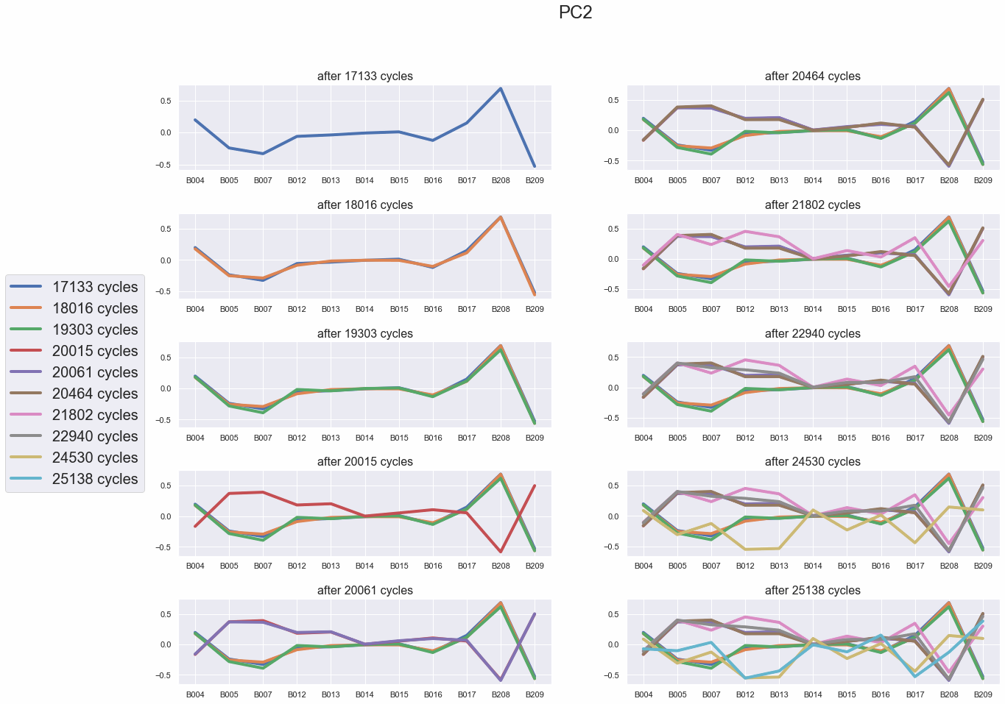
Figure 1. Example of anomaly detection during full scale fatigue test by means of the Principal Component analysis (PCA). Note that the PCA response changes after 20,015 cycles, indicating crack nucleation nearby

References

- Freed Y., G280 Executive Jet – Full Scale Fatigue Testing, 52nd Israel Annual Conference on Aerospace Sciences, 2012, Tel Aviv, Israel.
- Buimovich Y., Freed Y., Noivirt G. and Matias C., A summary of the G280 executive jet full scale fatigue test, 56th Israel Annual conference on Aerospace Sciences, 2016, Tel Aviv, Israel
- Sause, M. G., Schmitt, S., & Kalafat, S. (2018). Failure load prediction for fiber-reinforced composites based on acoustic emission. Composites Science and Technology, 164, 24-33.
- Patel, D. K., Parthasarathy, T., & Przybyla, C. (2020). Predicting the effects of microstructure on matrix crack initiation in fiber reinforced ceramic matrix composites via machine learning. Composite Structures, 236, 111702.
- Zobeiry, N., Reiner, J., & Vaziri, R. (2020). Theory-guided machine learning for damage characterization of composites. Composite Structures, 246, 112407.
- Reiner, J., Vaziri, R., & Zobeiry, N. (2021). Machine learning assisted characterisation and simulation of compressive damage in composite laminates. Composite Structures, 273, 114290.
- Freed Y., Zobeiry N. and Salviato M. (2022), Development of aviation industry-oriented methodology for failure predictions of brittle bonded joints using probabilistic machine learning, Composite Structures, 297: 115979
- Freed Y., Salviato M, and Zobeiry N. (2022), Implementation of a probabilistic machine learning strategy for failure predictions of adhesively bonded joints using cohesive zone modeling, International Journal of Adhesion and Adhesives, 118: 103226
- Freed Y. (2022), Implementation of machine learning strategies for determination of finite width correction factors for orthotropic plates containing central hole, Journal of Composite Materials, 56(28), p. 4221-4230
- Shoham S., Dorfman B., Kressel I. and Tur. M., Structural Characteristics Pattern Recognition Algorithm for Health and Usage Monitoring, 58th Israel Annual Conference on Aerospace Sciences, 2018, Tel Aviv, Israel
- Ofir Y., Kressel I., Ben-Simon U., Bohbot J. and Tur. M., Real-Time Structural Health Monitoring of aero-nautical structures using PCA-Based statistics, 10th European Workshop on Structural Health Monitoring, 2022, Palermo, Italy

