Improvement of the ECL-B3 test rig for better performance and phenomena characterization

Benoit Paoletti, Anne-Lise Fiquet, Alexandra Schneider, Cédric Dubois, Sébastien Goguey, Christophe Brandstetter, and Xavier Ottavy,
Université de Lyon, Ecole Centrale de Lyon, CNRS, LMFA, UMR 5509, F-69134, ECULLY, France
Abstract.
Even though they may appear expensive, tests on realistic high-speed configurations remain necessary to validate the designs of modern compressors and fans. This is because the modeling used in design tools does not account for all the complexity of physical phenomena and provides an approximate solution for flows in these machines. Some phenomena, such as fluid/structure interactions, require highly sophisticated solvers and are usually overlooked. Posterior checks are made on certain criteria to ensure that the risks of unstable phenomena are low. Experiments, on the other hand, encompass all the physics and also have the advantage of providing precise measurements of geometry and phenomena that are not simulated. Here, we think of multi-physics phenomena (fluid/structure interaction, acoustic modes/separations, geometric non-uniformities, etc.). However, to characterize a phenomenon, it is necessary to be able to make measurements with a high level of precision while controlling test conditions. The quality of measurements (and associated uncertainties) continues to improve and has now reached sufficiently precise levels to accurately describe the phenomenon under study. However, control over test conditions and geometry is much more problematic. Whether it is the machine's supply conditions, upstream flow non-uniformities, geometric defects, or disturbances present and generated by the setup, all of these introduce uncertainties that have consequences on physical phenomena and prevent clear deductions regarding the onset, triggering, or strength of these phenomena.

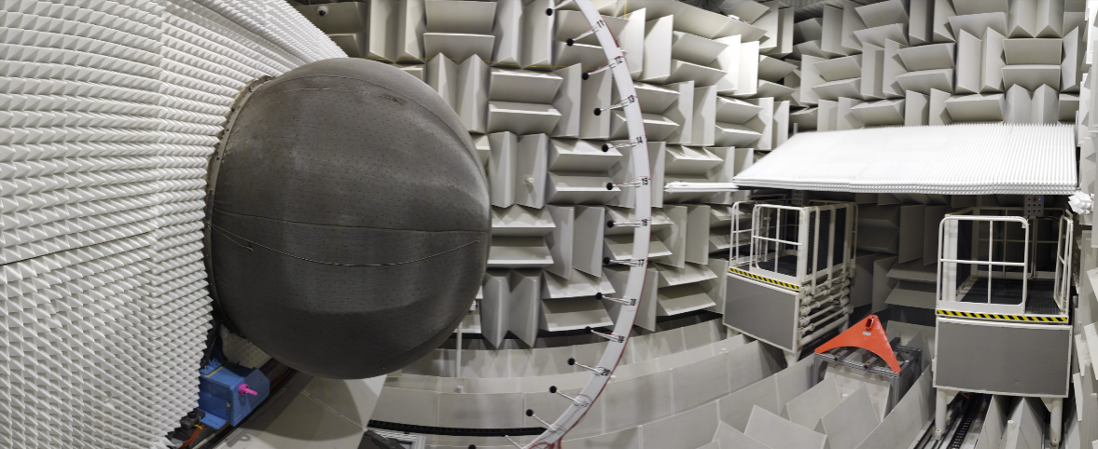
Fig 1. :ECL-B3 test rig at LMFA. Performance and multiphysic phenomena characterisation of modern fans.
This paper presents the study conducted at LMFA to improve the supply conditions of the ECL-B3 test rig, designed to test the performance and aeroelastic and acoustic behavior of composite fan blades (cf. fig. 1). More specifically, it is explained how the implementation of a deflector in the anechoic chamber, that provide the inlet conditions, and a wall around the machine's inlet have improved the inlet flow and contributed to the uniformity of the temperature and turbulence field at the air intake of the machine. In addition, a clearance and tip timing measurement system has been installed to complement the measurement chains on this rig. The results are presented and show that it is possible to distinguish each blade and observe the influence of clearance on the flow. The exit conditions and the natural frequencies of the test rig were also analyzed, and a modification of the rig by incorporating a Helmholtz resonator improved the frequency content of the flow in the vicinity of the fan when it approaches its operational limits.

