Entropy Analysis of Data Reduction Method

Terezie Kreuzová  *Czech technical university in Prague, Faculty of Mechanical Engineering, Prague, Czech Republic **Institute of Thermomechanics of the Czech Academy of Sciences, Prague, Czech Republic | Pavel Šafařík  *Czech technical university in Prague, Faculty of Mechanical Engineering, Prague, Czech Republic **Institute of Thermomechanics of the Czech Academy of Sciences, Prague, Czech Republic
David Šimurda
Institute of Thermomechanics of the Czech Academy of Sciences, Prague, Czech Republic

Abstract
Data Reduction Method is examined from the point of view of entropy production. It is shown that the method changes overall thermodynamic entropy of the reduced data. Upper bound of the entropy produced by Data Reduction depending on the input data is derived. To evaluate the influence of this production on integral characteristics of the flow, such as loss coefficient, a particular modification of Data Reduction Method with conservation of entropy is proposed. The original method and the modified one are tested on numerically obtained data. Although in studied cases the influence of increased entropy flux is small, if high precision is desirable, information about position of traversing plane should be integral part of any report utilizing Data Reduction Method.

introduction
The Data Reduction Method, as described for 2D analysis e. g. in [1-2], can be perceived as an operator which converts a vector of states X ($x_{i}=\left[ρ_{i},T_{i},p_{i},w_{xi},w_{yi}\right]$) into a single representing state $\tilde{x}=\left[\tilde{ρ},\tilde{T},\tilde{p},\tilde{w_{x}},\tilde{w_{y}}\right]$. The operator ensures that mass, momentum and energy flux are conserved. Balances of conservation of mentioned properties accompanied by equation of state of perfect gas form a system of five equations with five unknowns and therefore no other constraint can be introduced into such system and zero increase of entropy flux is not assured. Change of entropy flux leads to change of integral characteristics such as loss coefficient, therefore it is desirable to find maximum produced entropy by Data Reduction to allow evaluation of maximum error in such characteristics.
RESULTS and DISCUSSION
Entropy flux is defined in the same manner as fluxes defined in [2]:
$$I_{S}=\frac{1}{t}\int_{\left(t\right)}{ρ\left(y\right)w_{x}\left(y\right)s\left(y\right) \text{dy}}$$ | (1)
Using properties well known in calculus, upper limit of entropy produced by Data Reduction ($σ$), with assumption that the traversing plane does not intersect an area with reverse flow, can be found:
$$σ=\tilde{s}-\frac{I_{S}}{I_{M}}=\left(c_{p} \text{ln} \tilde{T}-r \text{ln} \tilde{p}\right)-\frac{I_{S}}{I_{M}}$$ | (2)
$$σ≤\text{min}\left[\int_{\left(t\right)}{\left|\frac{\text{d}s\left(y\right)}{\text{d}y}\right|\text{d}}y,t \text{max}\left|\frac{\text{d}s\left(y\right)}{\text{d}y}\right|\right]$$ | (3)
To test the relation (3), (2) is evaluated for a data set resulting from numerical simulations of the flow in a transonic compressor rotor blade cascade described in [4]. The results of the comparison are shown in Fig. 1. From 1a. it is clear that (3) is rather strict, but cases with higher upper limit also have higher actual entropy production and vice versa. 1b. shows there is a relation between position (dimensionless distance from blade cascade relative to the chord of the blade) of traversing plane and produced entropy, which is consistent with the conclusion that can be drawn from (3). Again, this relation is manifested in both, theoretical upper bound and obtained value.
To evaluate the influence of entropy production on a loss coefficient, slight modification of Data Reduction Method is proposed. Equation assuming constant total temperature is replaced by an identity $σ=0$. In contrast to the original method, the resulting set of equations needs to be solved numerically, but has a unique solution, while the original one leads to a biquadratic equation with two roots. With this reduction method applied on previously mentioned data, the results – compared to the results of the original method – differ only by tenths of percent for each variable (even integral characteristics) and for all cases $\tilde{T_{0}}∈\left(\text{min}\left(T_{0}\left(y\right)\right), \text{max} \left(T_{0}\left(y\right)\right)\right)$.
Following the findings of this work, the position of traversing plane should be reported alongside reduced data, as the results of the Data Reduction, although only to a limited extent, are dependent on it. Also, especially for cases with reverse flow or non-periodicity – as these are not simple to analyze theoretically – increased attention should be paid to entropy production to ensure significant additional error is not introduced into loss coefficient calculation.

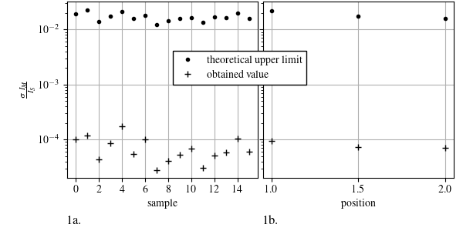
Figure 1. Theoretically predicted specific entropy production vs. values obtained on numerical data

ACKNOWLEDGMENT
Authors would like to express their gratitude to the Grant Agency of the Czech Technical University in Prague for supporting this work under the grant SGS23/105/OHK2/2T/12. Support by the Ministry of Education, Youth and Sports of the Czech Republic in the framework of the Program Inter-Excellence II under project LUAUS23231 is also gratefully acknowledged.
References
1. J. Amecke and P. Safarik, (1995)
2. P. Safarik, M. Luxa, J. Benetka, and J. Michálek, (2004)
3. M. L. G. Oldfield and J. H. Nicholson, (1981)
4. H. A. Schreiber and H. Starken, Journal of Engineering for Gas Turbines and Power 106, 288 (1984)

