NOVEL STABILITY IDENTIFICATION METHOD FOR TURBOMACHINERY APPLICATED SCHLIEREN SYSTEMS

Michail Tsinoglou  Anestis Kalfas | Beni Cukurel,  Abhijit Mitra | Alexandros Terzis
Aristotle University of Thessaloniki,  Laboratory of Fluid Mechanics and Turbomachinery,  Department of Mechanical Engineering, GR-54124,  Thessaloniki, Greece | Technion - Israel Institute of Technology,  Turbomachinery and Heat Transfer Laboratory,  Department of Aerospace Engineering, IL- 3200003,  Haifa, Israel | Technion - Israel Institute of Technology,  Thermo-Fluids and Interfaces Laboratory,  Department of Aerospace Engineering, IL- 3200003,  Haifa, Israel

ABSTRACT
The current work introduces a novel uncertainty identifying method of a turbomachinery schlieren measurement due to system vibrations. The method is applied on a schlieren system built around a transonic linear cascade used for micro gas turbine experiments.
The calculation process is based on the fluctuations of the light intensity in density-gradient-free areas caused by knife’s edge vibrations. The method is applied on transonic flow of 2 bar total inlet pressure passing around 7 scaled-down NASA C3X vanes for micro-turbomachinery applications. The vibration identification method was applied in 2 cases of transonic flow for 2 knife’s edge orientations. The physical amplitudes of the relative vibrations and the density gradients error were extracted as a result of the method’s application. The trend of vibrations in the 2 cases is matching, with the case of horizontal cutoff resulting to the higher vibration amplitude. By increasing the rigidity of the linear cascade an overall error decrease was observed, confirming that the source of the error is the deformation vibrations of the optical system.
The significance of this method is attributed to the measurement of vibrations without any extra instrumentation. The measurement is made exclusively by the optical system and can be used to detect vibration of any schlieren system with optical access to density-gradient-free areas.

INTRODUCTION
In the scope of identifying the aerodynamic performance of micro gas turbine blades a schlieren system was set around the Transonic linear cascade of Turbomachinery and Heat transfer Laboratory facilities at Technion Institute of Technology. The specific cascade is designed to run experiments on micro gas turbine blades with many varying parameters such as inlet Mach, Reynolds number, inlet pressure, inlet temperature, stager and incidence angle as described in detail by E. Yakirevich et al [3].
A schlieren image should have a uniform background with constant intensity throughout a recording process. The background intensity can change if the percentage of cutoff achieved by the knife’s edge position is changed. This change in percentage of cutoff can be caused by a change in the relative position of the razor blade with respect to the light beam. Theoretically if the whole schlieren system moves as one solid body the relative position of the razor should not change. Nonetheless, the setup is comprised of a series of many heavy optical components with each having its own spring constant thus vibrating in a deformative way. The deformation of the schlieren setup due to the load taken is observed mostly on the aluminum optical breadboard that supports the whole setup and it’s the cause of the relative movement of the knife’s edge.
In order to quantify the level of vibration due to deformation, a method based on schlieren image intensity change was devised. The vibrations are calculated based on the change in intensity in a region of the image with no flow meaning that every change in intensity is a pure result of the relative movement of the knife’s edge with respect to the light beam. The outcome of this method is an important indication of the stability and therefore the reliability of both the schlieren setup and the linear cascade.

METHODS
A region with no gradients is found in the lower part of the image which is isolated by the flow guiding tailboards. This area is marked with a red rectangle in Figure 1 for 3 cases of varying vibration amplitude.
a) | b) | c)
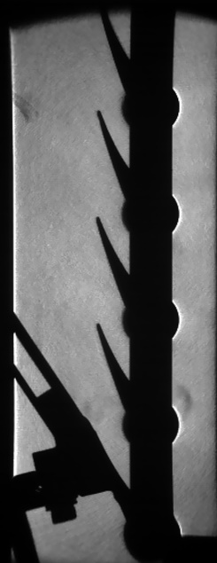 | 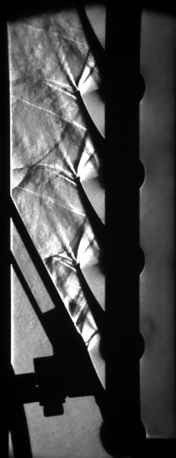 | 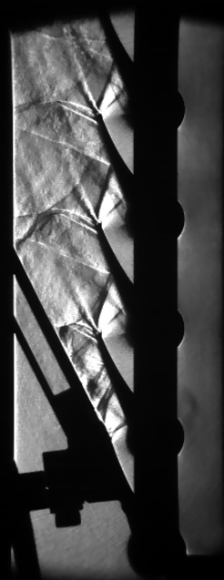
Figure 1. Region with no flow and varying intensity of vertical cutoff case a) reference image b) low amplitude vibrating moment c) medium amplitude vibrating moment

The average intensity of 100 images before the start of the phenomenon is taken as the reference intensity. For the case of vertical cutoff the knife’s edge range is measured to be 1.65 mm which is correlated to the percentage of cutoff with a 10% step (0mm-0% to 1.65mm-100%). Each step in the knife’s edge position results in a new calibration curve; the calibration curves resulted by the variation of cutoff are presented in Figure 2b. A polynomial surface is fitted to the set of the calibration curves in order to complete the gap between the discrete acquired data. The respective calibration images for 10% step change in cutoff are presented in Figure 2a. The calibration image acquisition process for the extraction of the calibration curve with respect to change in percentage of cutoff is explained by Tsinoglou [2].

a) | b)
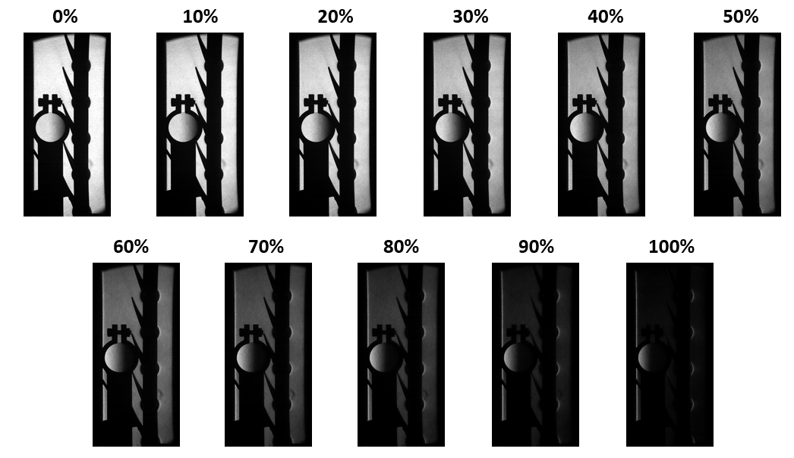 | 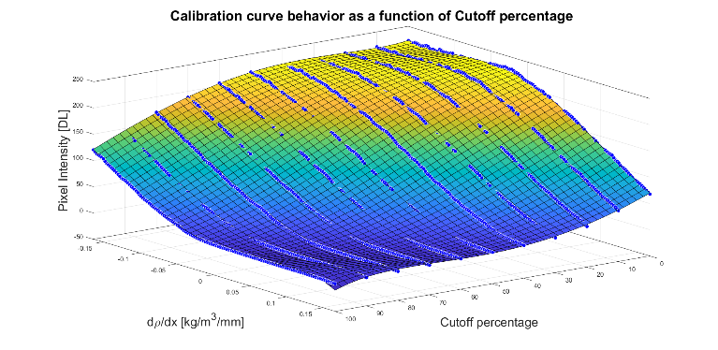
Figure 2. Calibration curve variation with cutoff a) acquired images b) calibration curves with fitted polynomial surface

The measured intensity in the isolated area allows the calculation of each frame’s real instantaneous cutoff though the calibration surface and the known density gradient. The density gradient error is calculated as the difference of the observed density gradient (instantaneous cutoff ) and actual density gradient (50% cutoff) as expressed in equation 1.
$${\frac{dρ}{dx}}_{Error}={\frac{dρ}{dx}}_{CO=CO(I)}-{\frac{dρ}{dx}}_{CO=50\%}$$ | (1)

EXPERIMENTAL SETUP
A calibrated z-type schlieren system with one more light beam folding was used for the optical measurements as shown in Figure 3. This type of system was chosen for its reliability and low aberration characteristics deeply explained by Settles [1]. The double folded schlieren configuration of Figure 3 has the advantage of bringing the heavy components such as the parabolic mirrors closer to the supports, minimizing the amplitude of the vibrations. The system is fixed on the cascade with 2 levels of optical tables which are mounted with each other with special high load air dampeners, in order to decouple the exciting forces of the cascade from the optical system.

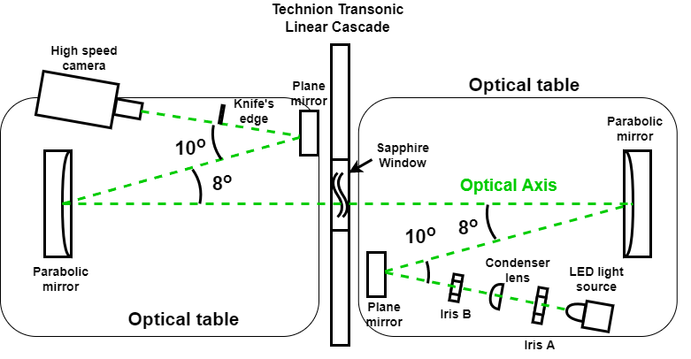
Figure 3. Schematic of schlieren experimental setup

RESULTS AND DISCUSSION
The method was first applied on the vertical knife edge configuration because the expected level of vibration was lower. The whole cycle of acceleration to deceleration of the flow lasted for 1.88 seconds. The maximal error in density gradients which corresponds to the maximum amplitude vibration for the vertical cutoff case is found to be equal to 0.075 $kg/m^{3}/mm$. The resolving range of the density gradients of the schlieren system is 0.4055 $kg/m^{3}/mm$ with the lower and upper boundary being -0.1873 and 0.2182 $kg/m^{3}/mm$ respectively. The average maximum detectable change in density is thus 0.2027 $kg/m^{3}/mm$. This indicates that the proportional error due to vibrations rises to 37.5% of the one-sided measurement range. As a conclusion, the error is significant and cannot be ignored. The error is observed to be reduced with the increase of the structure’s rigidity.
The result of the method applied in the first case of blowdown experiment (with vertical knife’s edge orientation) is presented in Figure 4. A Fast Fourier Transformation was applied in order to acquire the dominant frequencies of the phenomenon. Three main dominant frequencies of 3, 18 and 52 Hz were acquired. The maximization of the amplitude found to match the peak of the supersonic phase which occurs at 0.5 seconds after the experiment commencement. As a results, the error due to vibrations can be assumed to be related with the level of forces applied in the test rig and the rigidity of the structure.
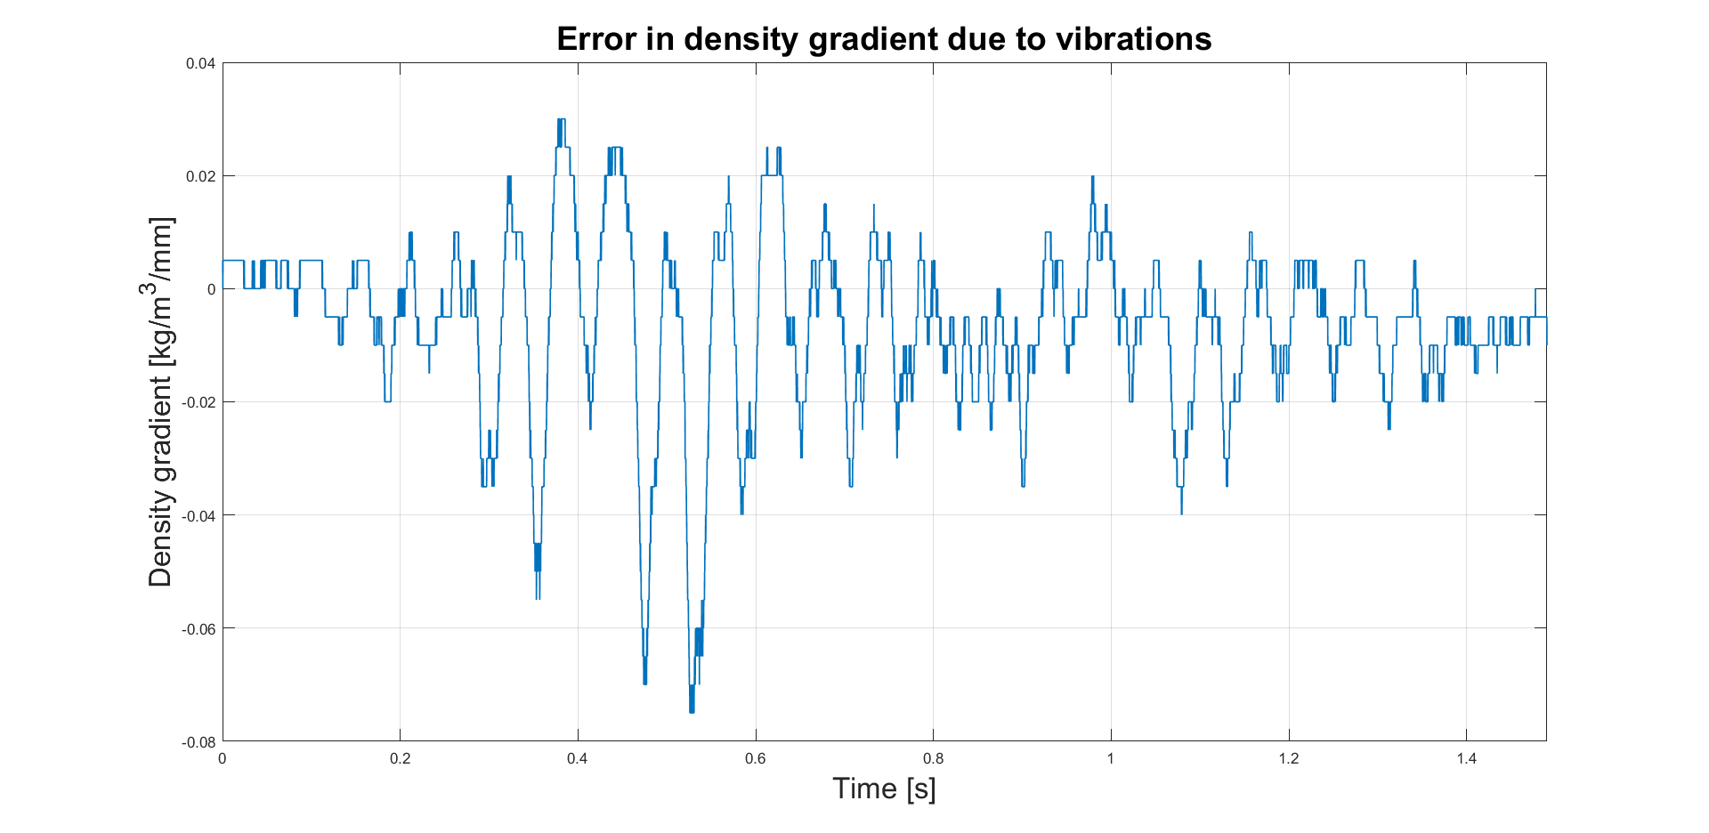
Figure 4. Error in density gradient measurement due to vibration of the knife edge with respect to schlieren light beam in a transonic blowdown

REFERENCES
- Settles, G. S. (2001). Schlieren and shadowgraph techniques: visualizing phenomena in transparent media. Springer Science & Business Media.
- Tsinoglou, D. M. (2022). Micro gas turbine blade Flow characteristics evaluation and acoustic flow control for pressure recovery using quantitative schlieren imaging. Master Thesis, Aristotle University of Thessaloniki.
- Yakirevich, E., Miezner, R., Leizeronok, B., & Cukurel, B. (2018). Continuous Closed-Loop Transonic Linear Cascade for Aerothermal Performance Studies in Microturbomachinery. Journal of Engineering for Gas Turbines and Power, 140(1).

