Evolution of a five-hole probe calibration NEAR a wall

Adrien VASSEUR
Institut Supérieur de l’Aéronautique et de l’Espace-SUPAERO, Toulouse, France
von Karman Institute for Fluid Dynamics, Rhode-Saint-Genese, Belgium
SAFRAN, Magny-les-Hameaux, France

Abstract
Five-hole probes (5HP) are a common tool for measurements of the velocity in turbomachinery studies. In those applications, the spaces are confined, which drives the probes to get close to walls. The proximity of the wall affects the behavior of the 5HP. The wall-related evolution of the calibration of two hemispheric L-shaped 3D printed five hole probes is investigated in a low speed wind tunnel. 2D Particle Image Velocimetry (PIV) and pressure measurements were carried out. The wall proximity causes the probe to measure that the flow goes away from the wall whereas the boundary layer causes the probe to feel that the flow direction is towards the wall.

introduction
Five-hole probes are a useful tool in turbomachinery measurements. They are robust and don’t require optical access. However, some problems are encountered when using them in this setting: their big size in the turbomachine veins affects the flow; they interact with nearby surfaces; the flow is different from the calibration flow which affects the way the data should be interpreted. In particular, near the walls of the vein, the probe blocks the flow and changes its direction [1]. The boundary layer on the wall adds complexity to the situation.
The tunnel used is the L-12 wind tunnel in von Karman Institude for Fluid Dynamics (VKI), that can reach Mach 0.05 at ambient temperature and pressure. The probes have a diameter of 8mm and 16mm. A flat plate with a sharp bevel was mounted in the test section to obtain a wall with a small boundary layer.
The calibration coefficients were measured at different distances from the flat plate, at two locations downstream the start of the flat plate to vary the boundary layer thickness.
RESULTS and DISCUSSION
Without the probe, the flow is parallel to the wall. The wall proximity effect appears from two to three diameters away from the wall. The probe measures a pitch diverging from the wall as it gets closer to the wall. The boundary layer has the opposite effect. These findings are coherent with the work of Bailey [1]. The magnitude of these two phenomena and their interaction will be analysed deeper once other experiments are finished in four weeks. One of those experiments is about the boundary layer effect away from the wall and will help understand the results of the experiment subject of this document.
No hysteresis was found when getting closer or further from the wall.
The experimental conditions are far from engine conditions. We are planning on using CFD to help learn about this problem in engine-like conditions.
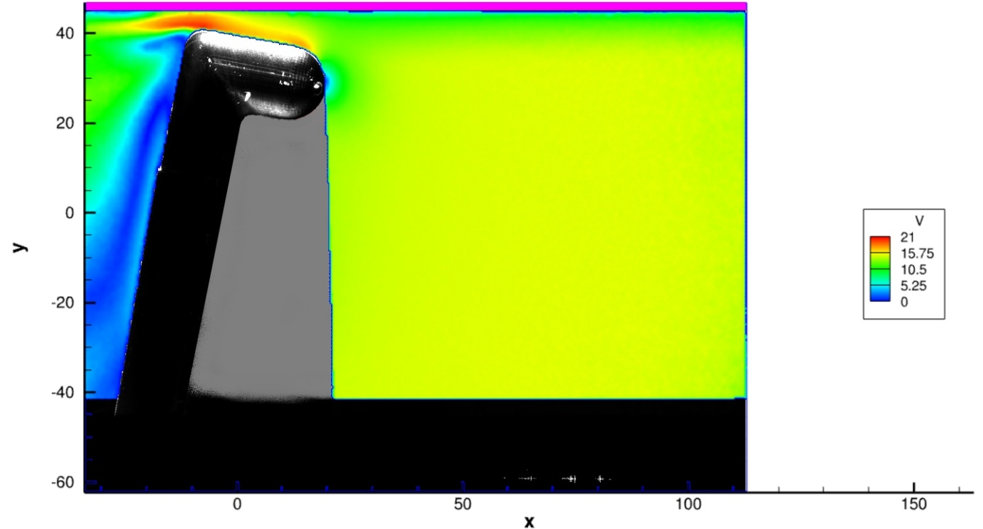

Figure 1. Velocity magnitude contour at 16ms/s, 10° pitch, 1 diameter away from the wall (purple)

References
[1] S. C. C. Bailey et al. Obtaining accurate mean velocity measurements in high reynolds number turbulent boundary layers using pitot tubes. Journal of Fluid Mechanics, 715 :642–670, jan 2013.

