remote laboratory experiments: Fan map generation and airfoil flow characterization

Konstantinos Eleftheriou  Aristotle University of Thessaloniki  elefthkd@auth.gr | Theofilos Efstathiadis  Aristotle University of Thessaloniki  theofil@auth.gr | Anestis I. Kalfas  Aristotle University of Thessaloniki  akalfas@auth.gr

Abstract
This paper presents the procedure followed to conduct two various experiments as part of the ‘Mechanical Laboratory’ course of the Mechanical Engineering department, at Aristotle University of Thessaloniki, during the Covid-19 period. Adapting to the personal contact restrictions imposed by the health issue outbreak, a remote experimental method is proposed. In the first experiment, the students had to generate the operational map of a cooling computer fan while on the second one the characteristic parameters of a symmetric airfoil needed to be measured. Multifunctional control panel interfaces were introduced to the students. Through these applications, the student had the opportunity to run the experiments, assess the raw data, monitor all the necessary flow parameters and acquire the important variables. The students had to post-process the results and submit two reports, one for each experiment. This teaching method provided the students with the experience of real research project and guided them to use modern tools to enhance the quality of their future work. This publication focuses on the address of the challenges, arose during the automation of the experiments. The remote experimental sessions indicated some advantages in learning procedure which was also reflected on the assignment grades. The development of the procedure has been successfully implemented and test over a couple of years while the quarantine measure have been in place. Furthermore, the experience gained will be used to implement modern communication protocols in the experimental set-ups.
RESULTS and DISCUSSION
The results shown that the students conducted effectively the experiments although they where outside of the lab. They understood in a better way the investigated phenomena because they could plot the acquired data in real-time and comment on these. Furthermore a higher level of grades was captured in the final exams which reveals the advantages of a remote experiment. Based on a survey conducted amongst the students, they said that they enjoyed this unique experience of controlling deferent devises remotely. They agreed also that the implementation of this teaching method should be continued. Finally, they proposed a number of improvements.

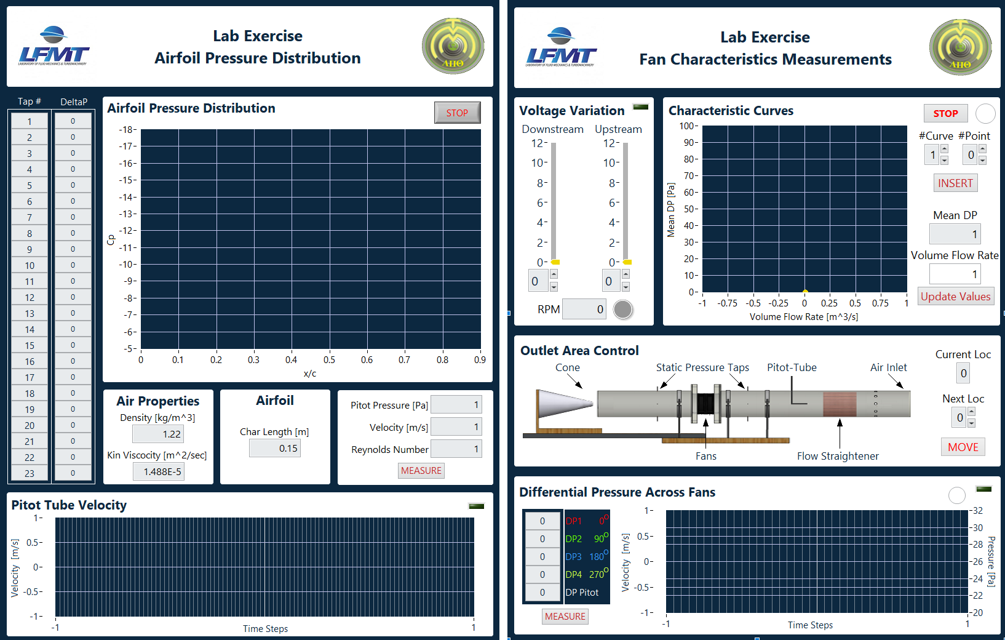
Figure 1. Experimental Control Panels

