Two-wavelength interferometry for measurement of transonic airflow in a compressor blade cascade

Pavel Psota, Jan Kredba, Marek Stašík,  Gramoz Cubreli, Vít Lédl  Technical University of Liberec, Faculty of Mechatronics, Informatics and Interdisciplinary Studies, Institute of New Technologies and Applied Informatics (NTI), Studentská 2, 461 17 Liberec 1, Czech Republic | David Šimurda  Institute of Thermomechanics of the Czech Academy of Sciences, v. v. i., Dolejškova 1402/5, 182 00 Praha, Czech Republic

Abstract
This paper presents high-speed two wavelength interferometry for measuring fast phenomena, which allows to extend the dynamic range of measurement using two different wavelengths at the same time. The method was applied to measure transonic airflow through a blade cascade.

introduction
Interferometry is one of the basic tools in the field of flow visualization. Digital interferometric methods using sensitive high-speed cameras make it possible to quantify the quantities of airflow fields with high accuracy and spatial resolution [1]. Interferometric techniques are based on "encoding" the optical phase of a wave to a measurable intensity in the form of interference fringes. In the case of steep or step changes in the measured quantity, the interference structure may be undersampled and thus information may be lost. Examples may be shock waves that show a step change in air density. For the measurement of phenomena with high gradients, where the undersampling of the fringe pattern occurs, it is possible to use two wavelength interferometry. The basic principles and examples of applications in the field of flow measurement are presented in this article.
RESULTS and DISCUSSION
Two wavelength interferometry for measuring rapidly evolving events is based on the recording of a multiplexed interference pattern, which includes interferograms from two laser independent sources with different wavelengths. Example of such interferogram is in Figure 1a. By setting the arrangement geometry, it is possible to control spatial carrier frequencies (density of fringes) making it possible to separate the two interferograms in Fourier domain and hence compute phase maps $φ_{1},φ_{2}$ for each wavelength. The difference between the phase maps $φ_{1},φ_{2}$ , is called synthetic phase map: $Φ={φ_{2}-φ}_{1}$that corresponds to the phase map as would be obtained with the synthetic wavelength: $Λ=λ_{1}λ_{2}/(λ_{2}-λ_{1})$. The synthetic wavelength $Λ$ is larger than the optical wavelengths and proportionally determines the range of unambiguousness. Such approach helps to overcome the 2$π$ ambiguity problem as well as allows for retrieval of phase information from undersampled fringes. The synthetic wavelength $Λ$ determines the accuracy of the measurement. In order to achieve interferometric precision of single wavelength, synthetic phase map is refined using the wrapped single wavelength maps in order to gain advantage from the both approaches: large measurement unambiguity of synthetic phase and accurate measurement of single wavelength phase. The retrieved and unwrapped optical phase can further be used for calculation of other quantities like density or isentropic Mach number.
As a proof of concept and demonstration of benefits of the proposed method, an investigation of supersonic flow through the tip-section turbine blade cascade is presented here. It is regime with inlet Mach number M_{in}~1.09. The isentropic Mach distribution measured by two wavelength interferometry is shown in Figure 1b. Flow features such as different types of shock waves are very well recognizable in the data.
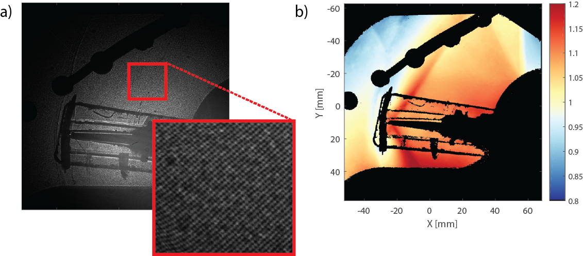

Figure 1. a) Multiplexed interference pattern; b) isentropic Mach number.

References
- Psota P, Cubreli G, Hala J, Simurda D, Sidlof P, Kredba J, Stasik M, Ledl V, Jiranek M, Luxa M, Lepicovsky J, Characterization of supersonic compressible fluid flow using high-speed interferometry. Sensors 21(23), 2021.

