HALF-SCALE TRANSONIC COMPRESSOR RAPID TESTING RIG

Tianhou Wang  Whittle Laboratory  University of Cambridge | James Taylor  Whittle Laboratory  University of Cambridge

Abstract
This paper presents a transonic compressor rig capable of rapid and accurate measurement of characteristic lines, which brings together many existing and new rapid testing techniques. A new rotor geometry can be manufactured in 3 days and mapped in one day.

introduction
High-speed rotating compressor rig tests deliver the ultimately reliable performance data, surpassing CFD and low-speed testing. However, the campaigns are usually lengthy (2-3 years) and very costly (~£20m), primarily because of the high mechanical integrity / safety requirements owing to the high energy involved.
This paper presents a transonic rapid testing compressor rig that strikes a compromise between physical realism and cost and time. This is done by bringing together many rapid testing techniques that used to form the highlight of individual rigs by themselves, drawing from the experience on the subject at the Whittle Laboratory.
RIG DESCRIPTION AND INITIAL RESULTS
The rig has one research compressor stage which is a half-scale replica of the first stage of an industrial axial compressor, driven by a single stage turbine to recycle the compressor work. The rotor diameter is 300 mm and the hub-tip ratio is 0.55. The mechanical arrangement is illustrated in Fig. 1. Both the real machine and the rig have atmospheric inlets, so full Mach number and half Reynolds number can be achieved.
An auxiliary suction fan drives the rig. The compressor is throttled by a variable bleed slot between the compressor and the turbine. A neural-network-based controller adjusts the suction pressure to maintain constant shaft speed as the compressor is throttled. The shaft speed is regulated to within 0.3% of the target.
Blade geometries can be easily changed. All components are manufactured by 5-axis machining from solid aluminum blanks. A new rotor geometry can be made in 3 days with machine and tooling at the ready.
The system has been proven to 25% design speed. For each geometry, the neural network controller is re-calibrated, which requires approximately 3 hours running. After this, four constant-speed characteristic lines can be measured within 30 minutes. Work is in progress to achieve full speed running.

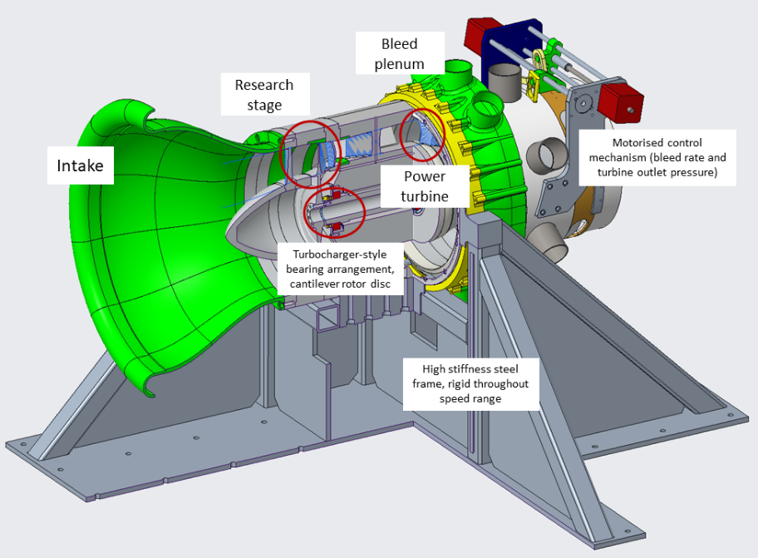
Fig 1: Mechanical arrangement of the rig (partial cutaway)

