EXPERIMENTAL INVESTIGATION OF TRANSIENT TEMPERATURE FLUCTUATIONS in a high-speed research compressor USING HOT-WIRE ANEMOMETRY and its challenges

Christian Schäffer, M.Sc. | Alexander Rabl,  M.Sc. | Dr.-Ing. Christian Helcig | Prof. Volker Gümmer

Abstract
Hot-wires are used in numerous applications, ranging from low air velocity HVAC systems to ultrasonic velocities in aerospace applications. Using thin hot-wires, extremely high-frequency response and high spatial resolution can be achieved compared to other measurement methods [1]. Probes with such a high temporal and spatial resolution are essential to resolve the flow field within modern high-speed compressors accurately. Acquired data might influence future compressor regular testing methods and design. Thus, reliable processes, data acquisition consistency, and an in-depth understanding of the hot-wire measurement technique are crucial for exceeding results.

introduction
Using specific parallel hot-wires, see Figure 1, a simultaneous determination of the unsteady flow temperature is possible in addition to the velocity measurement.
In turbomachinery or high-speed compressors, hot-wire probes are rarely used due to the relatively harsh conditions affecting the fragile wires with a diameter of d ≈ 1 to 9µm. Nevertheless, hot-wires are also suitable for high-resolution imaging flow fields inside high-speed compressors due to their small size.
The used hot-wire needs to be calibrated and tested in a calibration tunnel to validate the developed evaluation methods. The calibration range covers a Mach number between Ma ≈ 0.1 to 0.6. Furthermore, a traversing unit allows the yaw angle to be varied by more than ±90°, allowing the inflow direction influence to be investigated. Different flow temperatures in the calibration tunnel of up to 80°C enable a detailed reconstruction of the measured total temperature field. The probe used is a parallel hot-wire with gold or platinum-coated tungsten wires, with a diameter of d_{w} = 5µm and a wire length l_{w} = 1.25mm. This wire-aspect ratio results in a length-to-diameter ratio of l/d = 250. The distance between the parallel hot-wires is a_{w} = 0.4mm. The probe is operated according to the Constant Temperature Anemometry (CTA) principle. Different overheat ratios are used for the two wires. Using different overheats allows the temperature and the velocity to be measured simultaneously. The data recording rate for the hot-wire measurement is 300kHz. A square wave test is performed to verify that the time resolution is sufficient to characterize the unsteady flow field fluctuations. The hot-wires are used in the 3.5-stages high-speed research compressor (HSRC) in two different configurations, namely horizontal and vertical to the radial direction. These configurations allow the investigation of the inflow angle effect on the hot-wire measurement and the magnitude of the turbulence level within the flow in two spatial directions.
RESULTS and DISCUSSION
The paper will give a short overview of the process of the total temperature measurement, which is inspired by Jaffa et al. [2], Yablochkin, and Cukurel [3], and its validation in the institute's calibration tunnel. The main focus is on the challenges of using hot-wires in a high-speed research compressor environment. First of all, the calibration of hot-wires at higher mass flow densities but lower Mach numbers is necessary to avoid breaking the wires already during the calibration. This is realized by applying a pressure chamber at the calibration tunnel to raise the ambient pressure up to the level in the HSRC. Secondly, vibrations occur during the measurements in the compressor that disturb the raw signal. A detailed analysis is conducted via vibe sweeps and different modifications of the hot-wire hardware to find the source of the disturbances. Thirdly, the hot-wires show significant aging effects by accumulating dirt on the wire. This effect can be corrected via a post-test calibration.
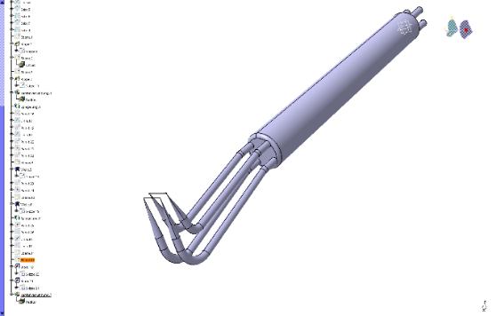
References
Figure 1: Vertical and horizontal parallel hot-wires
[1] Epstein A. H., "High Frequency Response Measurements in Turbomachinery.", Measurement Techniques in Turbomachines, 1, 1985.

[2] Jaffa N., Cameron J., and Morris S. C., "Phase Resolved Hot-wire Measurements for High-speed Turbomachinery Flows", 50th AIAA/ASME/SAE/ASEE Joint Propulsion Conference, American Institute of Aeronautics and Astronautics, Reston, Virginia, p. 337, 2014.

[3] Yablochkin E., and Cukurel B., "Multi-Hotwire Probe Sensitivity Optimization in Constant Temperature Anemometry (CTA) for Transonic Flows", XXIII Biannual Symposium on Measuring Techniques in Turbomachinery - Transonic and Supersonic Flow in Cascades and Turbomachines, Stuttgart, 2016.

