Laser triangulation measurement of blade oscillation
in a transonic compressor cascade

Petr Šidlof, Pavel Šidlof, Martin Štěpán  Technical University of Liberec, NTI FM, Studentská 2, Liberec, Czech Republic | David Šimurda, Jan Lepicovsky  Institute of Thermomechanics, Czech Academy of Sciences, Dolejškova 5, Prague, Czech Republic

Abstract
Using a new facility for blade flutter research at transonic regimes, the amplitude of blade oscillation was measured using a laser triangulation sensor for a range of inlet Mach numbers and blade oscillation frequencies. Nonlinear calibration of the sensor based on analytical derivation helped to reduce the measurement error by an order of magnitude. The blade amplitude at mid-span strongly increases with the frequency of oscillation, and also depends nontrivially on the flow velocity.

introduction
During last three years, a new facility for research of flutter in turbine and compressor blade cascades under transonic flow conditions was designed (Lepicovsky, 2021). In this facility, the middle blade in the cascade undergoes high-frequency torsional oscillations with kinematic excitation imposed by the blade drive mechanism (see Fig. 1). In the current study, the angular amplitude at the blade driving shaft is set to 1 deg.

Methods
The blades are instrumented with Kulite dynamic pressure transducers, and the aerodynamic and inertial torque is measured by strain gauges. To monitor the angular deflection of the blade at mid-span, a fast-response laser triangulation sensor MicroEpsilon ILD 2310-40 is used, with a measuring range of 20 mm, resolution 0.6 μm and measuring rate up to 49 kHz. This optical sensor measures the vertical displacement near the leading edge of the blade, which is then converted to angular deflection. However, due to the curvature of the blade, the relation between the angular and vertical displacement proved certain degree of nonlinearity.

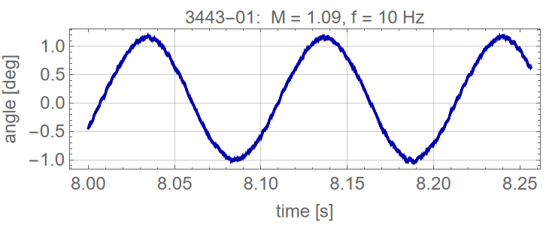
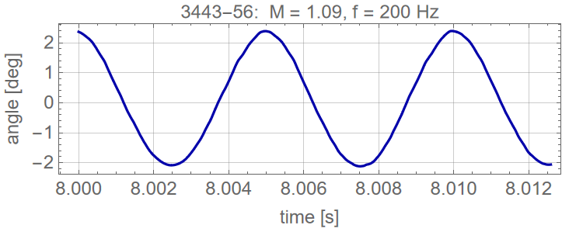
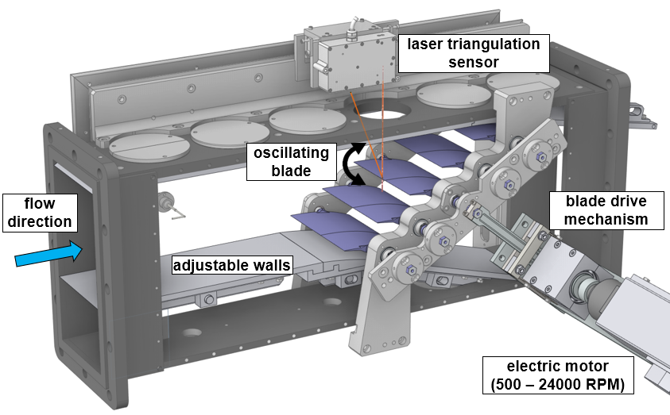

Figure 1. Test section with the laser triangulation sensor (left). Angular displacement of the oscillating blade for inlet Mach number M = 1.09, oscillation frequency f = 10 Hz and f = 200 Hz (right).

RESULTS and DISCUSSION
The relation between the vertical displacement of the laser spot near the leading edge and the angular deflection of the blade was derived analytically for a blade with a geometry of a compressor rotor developed at German Aerospace Center (DLR) (Schreiber, 1984). The results show that using a simple linear fit can introduce an error of angular deflection measurement up to 0.05 deg for an ideally aligned setup, and up to 0.1 deg if the laser beam is not perfectly vertical. When a quadratic (square-root) fit is used, the error is reduced by an order of magnitude.
Based on the analytical results, the calibration curve was measured on the blade cascade, approximated by a square-root fit and used in wind tunnel measurements with inlet isentropic Mach number ranging between
$M=0.7-1.09$ and frequencies of blade oscillation $f=10-200 Hz$. For low frequencies, the blade oscillates as a rigid structure with an angular amplitude close to 1 deg. At higher frequencies, the blade deforms elastically with an amplitude of up to 2.4 deg at mid-span (see Fig. 1). The blade deformation also depends on the flow velocity in the cascade, with highest amplitudes for inlet Mach numbers between $M=0.9-1.0$ .

References
Lepicovsky J., Šidlof P., Šimurda D., Štěpán M., Luxa M. (2021), New test facility for forced blade flutter research, AIP Conference Proceedings, pp. 030001
Schreiber, H.A. and Starken, H. (1984), Experimental Cascade Analysis of a Transonic Compressor Rotor Blade Section”, J.of Eng. for Gas and Power, 106, pp. 288-294.

acknowledgements
The research was supported by the Ministry of Education, Youth and Sports of the Czech Republic, project No. LTAUSA19036 Advanced experimental research on synchronous and non-synchronous blade vibration.

