Data Acquisition, Control and Processing of the Purdue Experimental Aerothermal Laboratory

Lakshya Bhatnagar  Purdue University  Papa Aye N. Aye-Addo  Purdue University | Guillermo Paniagua  Purdue University

Abstract
The Purdue Experimental Aerothermal Laboratory (PETAL) is a pressure driven facility capable of steady state and transient testing with three different test sections of increasing technology readiness level (TRL). These go from a linear wind tunnel, an annular cascade and a full rotating turbine test module. Higher TRL indicates greater fidelity towards the final application of the test article. In this manuscript we describe the increasing complexity requirement of the data acquisition and control system with increase in TRL and how it was implemented for the PETAL facility. The impact this architecture has on the uncertainty of the measurement is presented. The processing code is also presented that is able to combine data from different data acquisition systems and is flexible enough to be applied to all test sections

introduction
Data acquisition and control is an important part of the design of experimental rigs. The design and implementation of it also creates restrictions on the experimental setup. This manuscript presents the implementation of the data acquisition and control system for the Purdue Experimental Aerothermal Laboratory. The effect of the data system on the measurement uncertainty is also quantified.
RESULTS and DISCUSSION
A distributed architecture is implemented for all three systems with local control and condition systems which are all then communicated and controlled with central machines. The facility employs primarily three main communication modes. The Data Acquisition and Control system is divided into three independent systems viz. Control, Performance and Health and Safety. This was done to meet the conflicting requirements of each system. An automated post processing code is presented that is able to take data from the different data acquisition systems in their raw format and is able to combine and output data in a hierarchical format for easy analysis.
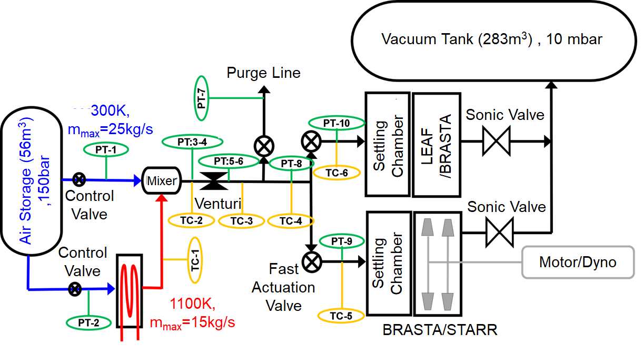

Figure 1. Layout of the PETAL facility highlighting instrumentation used for flow control.

References
Put references here should it be required.

