on piezoelectric energy harvesting for autonomous sensing in turbomachinery

Antiopi-Malvina Stamatellou  Aristotle University of Thessaloniki, Greece | Anestis I. Kalfas  Aristotle University of Thessaloniki, Greece

Abstract

Piezoelectric energy harvesters convert mechanical stresses caused by ambient vibrations into electric energy. The extracted energy is then used to power wireless sensor network nodes. Vibrational energy can be harvested by piezoelectric transducers through utilization of unsteady flow phenomena for flow-induced vibration or mounting of harvesters on vibrating structures and use of mechanical vibration. The performance of piezoelectric energy harvesters highly depends upon the source’s vibration frequencies. Hence, turbomachines and other rotating machinery present appropriate vibration energy source opportunities because of their stable mechanical vibration frequencies and unsteady flow phenomena. In this paper experience from the use of a commercial piezoelectric transducer (MIDE technologies) for energy harvesting from centrifugal fans to realize autonomous sensing is presented. The voltage output produced by this type of transducer is correlated to the speed and balancing condition of the machinery.
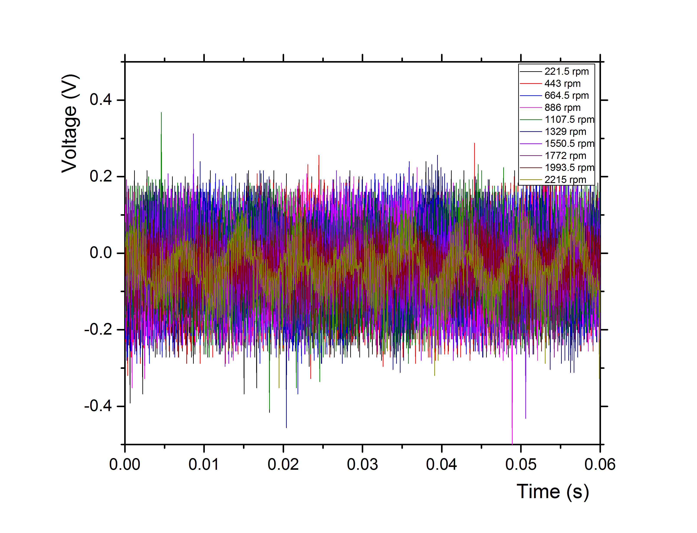

Figure 1. Measured voltage output waveforms for different fan speeds

