turbocompressor test facility operating with helium-neon gas mixtures of varying mixing ratios

Maxime Podeur - University of Stuttgart | Damian M. Vogt - University of Stuttgart

Abstract
A turbocompressor test facility designed to operate with different mixtures of helium and neon has been recently commissioned at the Institute of Thermal Turbomachinery and Machinery Laboratory. This paper gives an overview of the test rig and describes its architecture, components and operation. Moreover, after having validated the aerodynamic performance of a newly designed centrifugal compressor stage, the impact of Reynolds number on the performance is investigated at different gas mixtures. Results are then compared to models described in the literature.

introduction
Within the framework of the Future Circular Collider (FCC) currently being investigated at CERN, the entire cryogenic cycle required to maintain a temperature level of the superconducting magnets near absolute zero had to be revised with respect to the existing Large Hadron Collider (LHC). Indeed, stringent heat load constraints, coming from a four times longer accelerator ring and twice higher magnetic fields, required a major revision of the entire cryogenic cycle. In particular, a novel pre-cooling cycle had to be developed for this purpose. This led to a closed-loop cryogenic cycle operating with a mixture of helium and neon, also called Nelium.
Even though screw compressors remain the technology commonly found in standard helium cryogenic cycle, using a turbocompressor instead shows a promising potential if the operating fluid is being ballasted with a heavy gas such as neon. Moreover, this new approach justified to bring together industry and research institutes including CERN, MAN Energy Solutions and the Institute of Thermal Turbomachinery and Machinery Laboratory (ITSM) at the University of Stuttgart. The main goal of this research consortium is to provide an efficient and economically viable solution for multi-stage turbocompressors operating with helium-neon gas mixtures.
To better understand the challenges and opportunities associated with the design and operation of radial compressors with such light gases, a closed loop test facility has been designed, built and commissioned at the ITSM. The test facility has been developed to operate with air as well as with helium-neon gas mixtures of varying mixing ratios ranging from pure neon to pure helium.
The test facility includes a preconditioning unit, in which the helium-neon gas mixture is prepared and its exact gas composition verified by means of a binary gas analyser tailored to this specific mixture. The preconditioned gas is then admitted to a closed test loop, where a high-speed motor supported by gas bearings directly drives a radial compressor impeller. The test rig architecture allows to adjust the gas mass inside the test loop as well as compressor inlet temperature and pressure as desired, which enables to measure and compare the compressor performance at different Reynolds numbers.
Moreover, aspects of flexibility have been considered in the design of the test facility such that different compressor stages can be mounted that differ in their impeller and diffuser geometry or in direction of the inlet flow (axial or radial inlet). Hence, after having designed a first exploratory compressor stage at low tip Mach number, the main objective of this test rig is to validate its aerodynamic performance experimentally for different gas composition before moving to other designs in a next step.

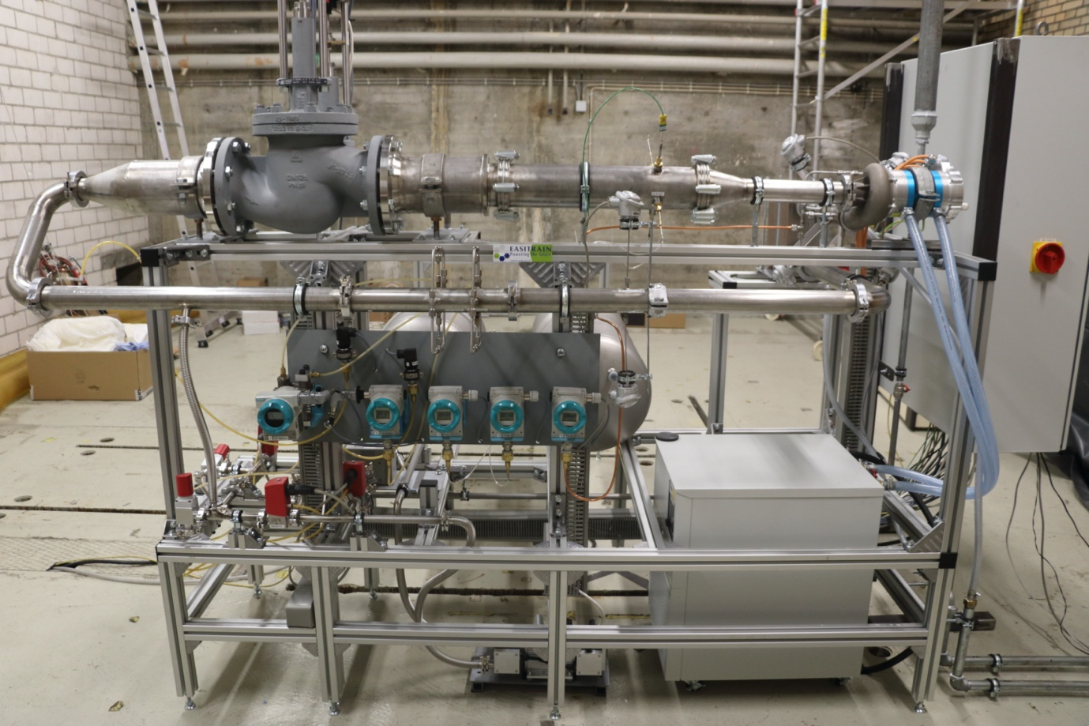

Figure 1. Picture of the Nelium turbocompressor test facility

